5

**AIM**

To model a simple HTML file describing your hometown (demonstrate the use of different tags).

**Program Code**

<html>

<head>

<Title>My Hometown </title>

</head>

<body style="background-color:Black;">

<H1 align="center" style="background-color:OliveDrab; color:white; font-family:Chiller;">Chalakudy</h1>

<img src="ckdy.jpg" alt="Chalakudy"style="width:1600px;height:400px";>

<h2 align="center"style="color:Olive"><q>The Charming city...</q></h2>

<p1 style="color:white">Chalakudy is a municipal town situated on the banks of Chalakudy River in Thrissur district of the Kerala state in India. It is the headquarters of Chalakudy taluk. It is the base camp for travellers to Athirappilly Falls and Vazhachal Falls. Chalakudy lies on National Highway 544 and located about 47 km (23 mi) north of the city of Kochi, and 30 km (19 mi) south of Thrissur.</p1>

<h3 style="color:Olive"><b>Etymology</b></h3>

<p style="color:white">History says during the second Chera dynasty, people outside kerala visited Chalakudy to learn vedas and Kalaripayattu from Chukkikulam Shala. These people lived in the banks of Chalakudy River and this accommodation is called Kudi. The combination of these two words Shalakudi is later modified into Chalakudy.</p>

<h3 style="color:Olive"><b>Administration</b></h3>

<p style="color:white">Chalakudy Municipality came into existence in the year 1970. The municipality covering an area of 25.23 km2 is divided into 36 electoral wards. Chalakudy is a Grade-II municipality. Chalakudy is an assembly constituency & Lok Sabha constituency. Benny Behanan (INC) is the current MP of the Parliamentary constituency and T J Saneesh Kumar Joseph (INC) is the current M.L.A. of Legislative Assembly Constituency.</p>

</body>

</html>

**Output**



**AIM**

Create a webpage for displaying your biodata which contains images, tables, and also link within a page.

**Program Code**

**BIO-DATA.html**

<html>

<head>

<title>BIO DATA </title>

</head>

<body>

<h1 align="center">BIODATA</h1>

<h3>Name : ATHUL P D</h3>

<img align="right" src="1264 athul.jpg"width="200" height="200">

<a href="personnal.html">Personnal Details</a><br>

<a href="academics.html">Academic Details</a>

</body>

</html>

**Personal details.html**

<html>

<head>

<title>Personal Details </title>

</head>

<style>

table, th, td {

border:1px solid black;

}

</style>

<body>

<h1 align="center">PERSONNAL DETAIL</h1>

<table style="width:50%">

<tr>

<td>Name</td>

<td>Athul P D</td>

</tr>

<tr>

<td>Age</td>

<td>22</td>

</tr>

<tr>

<td>Gender</td>

<td>Male</td>

</tr>

<tr>

<td>Religion</td>

<td>Hindu</td>

</tr>

<tr>

<td>Caste</td>

<td>Ezhava</td>

</tr>

<tr>

<td>DOB</td>

<td>13/12/1999</td>

</tr>

<tr>

<td>Mobile</td>

<td>813983xxxx</td>

</tr>

<tr>

<td>E mail</td>

<td>athuldasxx@gmail.com</td>

</tr>

</table>

</body>

</html>

**Academic details.html**

<html>

<head>

<title>Academic Details </title>

</head>

<style>

table, th, td {

border:1px solid black;

}

</style>

<body>

<h1 align="center">Academic Details</h1>

<table style="width:80%">

<tr>

<th>COURSE</th>

<th>INSTITUTION</th>

<th>BOARD/UNIVERSITY</th>

<th>PERCENTAGE</th>

</tr>

<tr>

<td>10th</td>

<td>L.F Public School,Muringoor</td>

<td>CBSE</td>

<td>CGPA 9.4</td>

</tr>

<tr>

<td>+2</td>

<td>L.F Public School,Muringoor</td>

<td>CBSE</td>

<td>72%</td>

</tr>

<tr>

<td>BCA</td>

<td>NIMIT, Pongam</td>

<td>University of Calicut</td>

<td>68%</td>

</tr>

</table>

</body>

</html>

**Output**

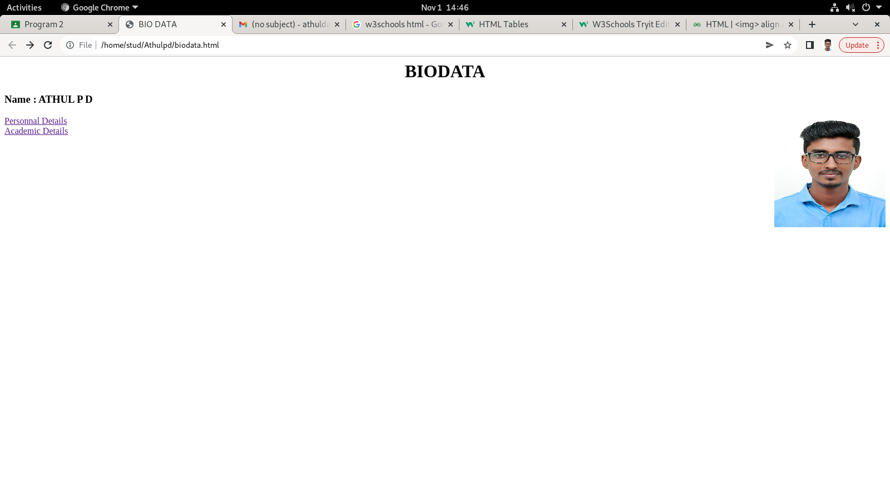

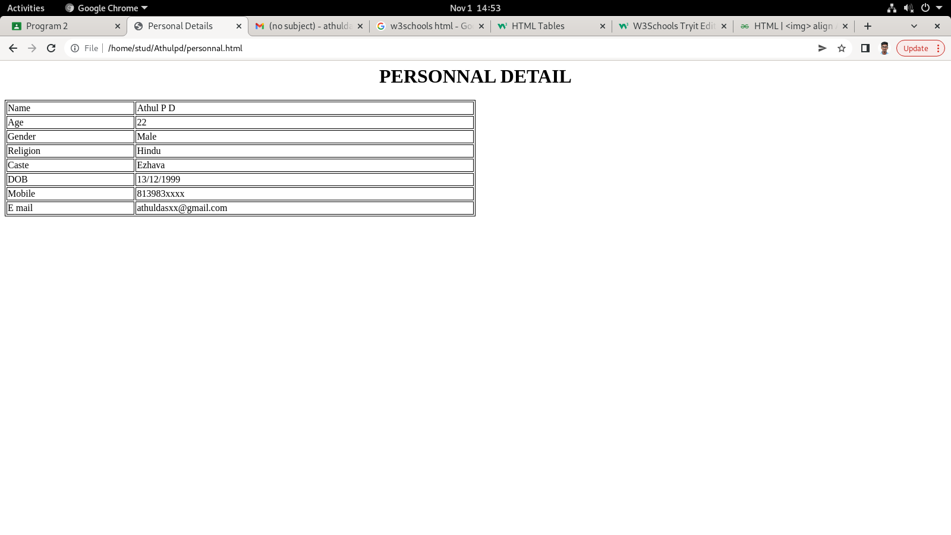

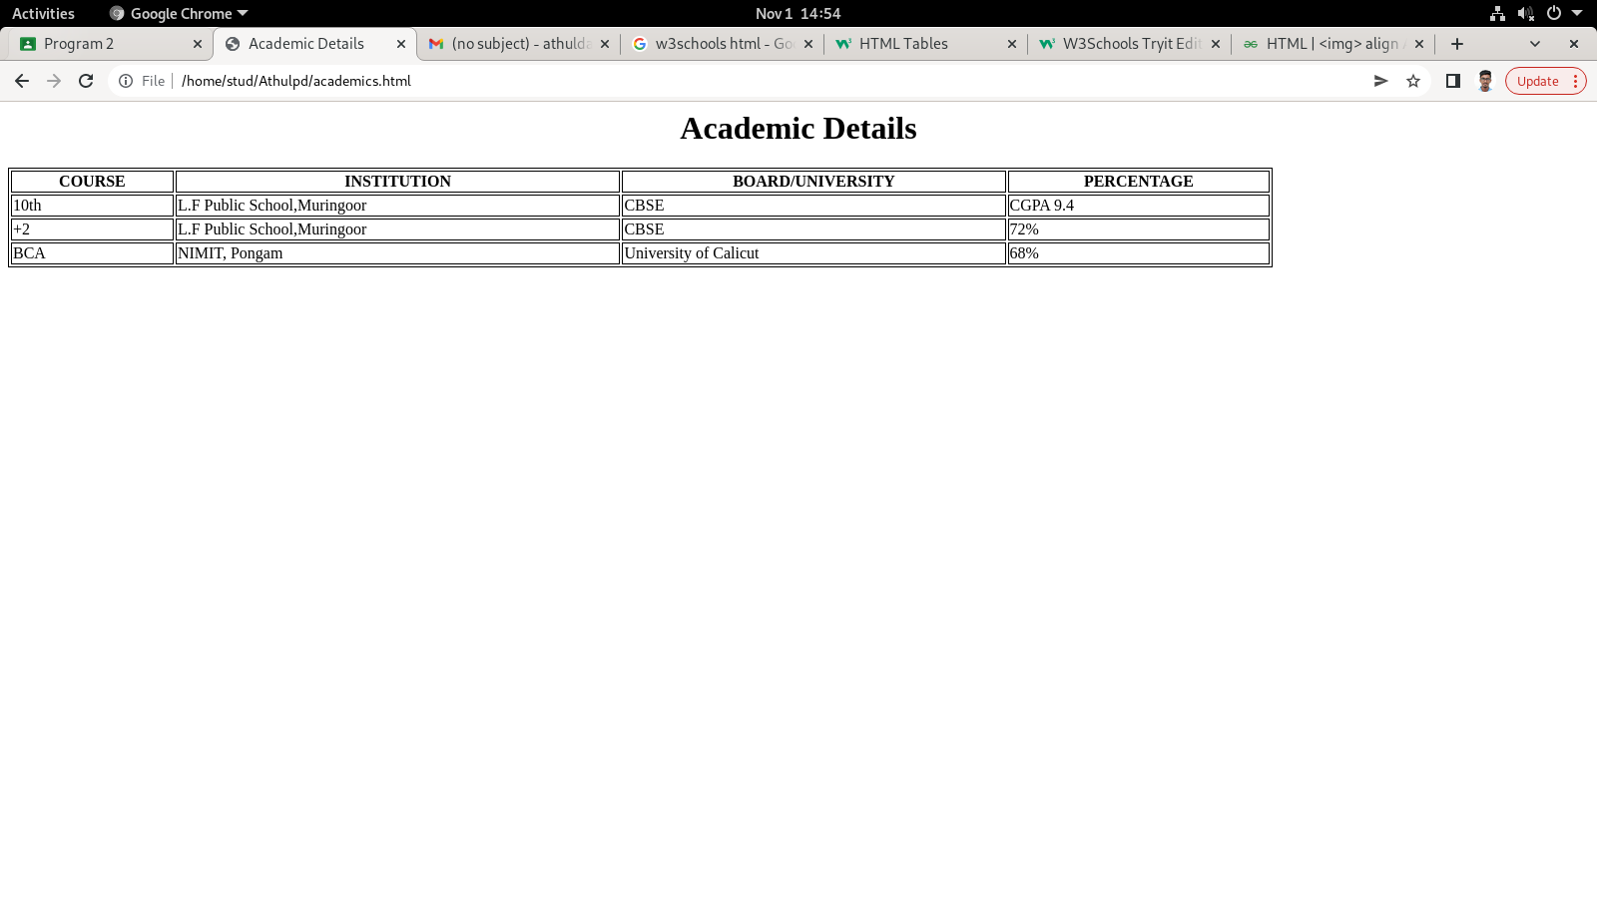

**AIM**

Design an application form for MCA course in Fisat using HTML.

**Program Code**

<html>

<head>

<title>MCA ADMISSION 2023</title>

</head>

<body>

<h1 align="center">MCA ADMISSION 2023</h1>

<form action="backend"method="post">

<table>

<tr>

<td>

<h3>First Name:</h3></td>

<td><input type="text" name="First name" size="30"autofocus>

</td>

</tr>

<tr><td>

<h3>Last Name:</h3></td>

<td><input type="text" name="Last name" size="20">

</td>

</tr>

<tr><td>

<h3>Address:</h3></td>

<td><textarea name="address" rows="3"cols="25"></textarea>

</td></tr>

<tr><td>

<h3>Pincode:</h3></td>

<td><input type="text" size="20">

</td>

</tr>

<tr><td>

<h3>Mobile:</h3></td>

<td><input type="text" name="Mobile" size="12"></td>

</tr>

<tr>

<td><h3>Email:</h3></td>

<td><input type="text" name="Email" size="30"></td>

</tr>

<tr>

<td><h3>DOB:</h3></td>

<td><input type="date" id="birthday" name="birthday"></td>

</tr>

<tr>

<td><h3>sex:</h3></td>

<td><input type="radio" name="male" value="m" >Male

<input type="radio" name="female" value="f" >False</td>

</td></tr>

<tr>

<td><h3>Marital Status:</h3></td>

<td><input type="radio" name="single" value="s" >Single

<input type="radio" name="Married" value="m">Married</td>

</td></tr>

<tr>

<td><h3>Background:</h3></td>

<td><input type="checkbox" name="Computer" value="CS" >Computer Science</td>

<td><input type="checkbox" name="Other" value="m" >Other</td>

</tr>

<tr>

<td>

<h3>10th Marks:</h3></td>

<td><input type="text" name="First name" size="30"autofocus>

</td>

</tr>

<tr>

<td>

<h3>Plus Two Marks:</h3></td>

<td><input type="text" name="First name" size="30"autofocus>

</td>

</tr>

<tr>

<td>

<h3>Degree Marks:</h3></td>

<td><input type="text" name="First name" size="30"autofocus>

</td>

</tr>

<tr>

<td><input type="submit" value="Submit">

</td>

</tr>

<tr>

<td><input type="reset" value="reset">

</td>

</tr>

</form>

</body>

</html>

**Output**

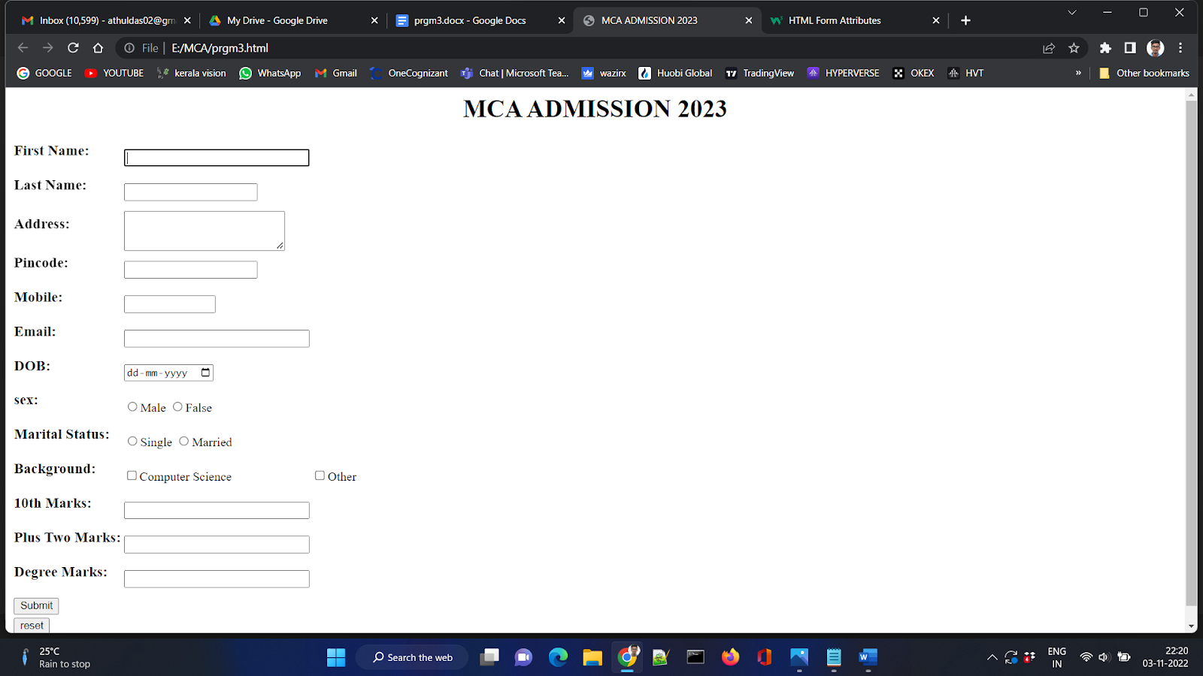

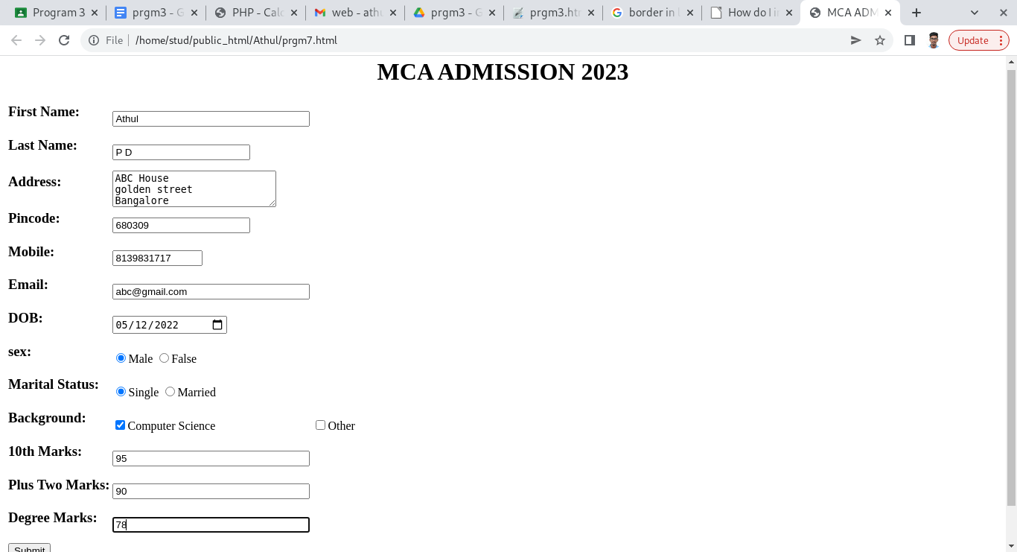

**AIM**

Create a HTML page with different types of frames such as floating frame, navigation frame & mixed frame.

**Program Code**

**Main Html**

<<html>

<head>

<title>Frames</title>

</head>

<frameset cols="140,*">

<frame name="navF" src="navigation.html">

<frame name="mainF" src="frames.html">

</frameset>

</html>

**Navigation html**

<html>

<head>

<title>Navigation Bar</title>

</head>

<body><center>

<h3>WELCOME ! </h3>

<a href="hometown.html" target="mainF">Program 1</a><br><br>

<a href="biodata.html" target="mainF">Program 2</a><br><br>

<a href="prgm3.html" target="mainF">Program 3</a><br>

</html>

**Frames Html**

<html>

<head>

<title>WP Lab</title>

</head>

<body>

<h2>Welcome to my basic Web Programming Lab Programs</h2>

<p>

<h4>Please select any program in the Navigation Pane</h4>

</p>

</body>

</html>

**Prgm3 html**

<html>

<head>

<title>MCA ADMISSION 2023</title>

</head>

<body>

<h1 align="center">MCA ADMISSION 2023</h1>

<form action="backend"method="post">

<table>

<tr>

<td>

<h3>First Name:</h3></td>

<td><input type="text" name="First name" size="30"autofocus>

</td>

</tr>

<tr><td>

<h3>Last Name:</h3></td>

<td><input type="text" name="Last name" size="20">

</td>

</tr>

<tr><td>

<h3>Address:</h3></td>

<td><textarea name="address" rows="3"cols="25"></textarea>

</td></tr>

<tr><td>

<h3>Pincode:</h3></td>

<td><input type="text" size="20">

</td>

</tr>

<tr><td>

<h3>Mobile:</h3></td>

<td><input type="text" name="Mobile" size="12"></td>

</tr>

<tr>

<td><h3>Email:</h3></td>

<td><input type="text" name="Email" size="30"></td>

</tr>

<tr>

<td><h3>DOB:</h3></td>

<td><input type="date" id="birthday" name="birthday"></td>

</tr>

<tr>

<td><h3>sex:</h3></td>

<td><input type="radio" name="male" value="m" >Male

<input type="radio" name="female" value="f" >False</td>

</td></tr>

<tr>

<td><h3>Marital Status:</h3></td>

<td><input type="radio" name="single" value="s" >Single

<input type="radio" name="Married" value="m">Married</td>

</td></tr>

<tr>

<td><h3>Background:</h3></td>

<td><input type="checkbox" name="Computer" value="CS" >Computer Science</td>

<td><input type="checkbox" name="Other" value="m" >Other</td>

</tr>

<tr>

<td>

<h3>10th Marks:</h3></td>

<td><input type="text" name="First name" size="30"autofocus>

</td>

</tr>

<tr>

<td>

<h3>Plus Two Marks:</h3></td>

<td><input type="text" name="First name" size="30"autofocus>

</td>

</tr>

<tr>

<td>

<h3>Degree Marks:</h3></td>

<td><input type="text" name="First name" size="30"autofocus>

</td>

</tr>

<tr>

<td><input type="submit" value="Submit">

</td>

</tr>

<tr>

<td><input type="reset" value="reset">

</td>

</tr>

</form>

</body>

</html>

**Hometown html**

<html>

<head>

<Title>My Hometown </title>

</head>

<body style="background-color:Black;">

<H1 align="center" style="background-color:OliveDrab; color:white; font-family:Chiller;">Chalakudy</h1>

<img src="ckdy.jpg" alt="Chalakudy"style="width:1600px;height:400px";>

<h2 align="center"style="color:Olive"><q>The Charming city...</q></h2>

<p1 style="color:white">Chalakudy is a municipal town situated on the banks of Chalakudy River in Thrissur district of the Kerala state in India. It is the headquarters of Chalakudy taluk. It is the base camp for travellers to Athirappilly Falls and Vazhachal Falls. Chalakudy lies on National Highway 544 and located about 47 km (23 mi) north of the city of Kochi, and 30 km (19 mi) south of Thrissur.</p1>

<h3 style="color:Olive"><b>Etymology</b></h3>

<p style="color:white">History says during the second Chera dynasty, people outside kerala visited Chalakudy to learn vedas and Kalaripayattu from Chukkikulam Shala. These people lived in the banks of Chalakudy River and this accommodation is called Kudi. The combination of these two words Shalakudi is later modified into Chalakudy.</p>

<h3 style="color:Olive"><b>Administration</b></h3>

<p style="color:white">Chalakudy Municipality came into existence in the year 1970. The municipality covering an area of 25.23 km2 is divided into 36 electoral wards. Chalakudy is a Grade-II municipality. Chalakudy is an assembly constituency & Lok Sabha constituency. Benny Behanan (INC) is the current MP of the Parliamentary constituency and T J Saneesh Kumar Joseph (INC) is the current M.L.A. of Legislative Assembly Constituency.</p>

</body>

</html>

**Biodata Html**

<html>

<head>

<title>BIO DATA </title>

</head>

<body>

<h1 align="center">BIODATA</h1>

<h3>Name : ATHUL P D</h3>

<img align="right" src="1264 athul.jpg"width="200" height="200">

<a href="personnal.html">Personnal Details</a><br>

<a href="academics.html">Academic Details</a>

</body>

</html>

**Academics html**

<html>

<head>

<title>Academic Details </title>

</head>

<style>

table, th, td {

border:1px solid black;

}

</style>

<body>

<h1 align="center">Academic Details</h1>

<table style="width:80%">

<tr>

<th>COURSE</th>

<th>INSTITUTION</th>

<th>BOARD/UNIVERSITY</th>

<th>PERCENTAGE</th>

</tr>

<tr>

<td>10th</td>

<td>L.F Public School,Muringoor</td>

<td>CBSE</td>

<td>CGPA 9.4</td>

</tr>

<tr>

<td>+2</td>

<td>L.F Public School,Muringoor</td>

<td>CBSE</td>

<td>72%</td>

</tr>

<tr>

<td>BCA</td>

<td>NIMIT, Pongam</td>

<td>University of Calicut</td>

<td>68%</td>

</tr>

</table>

</body>

</html>

**personnal.html**

<html>

<head>

<title>Personal Details </title>

</head>

<style>

table, th, td {

border:1px solid black;

}

</style>

<body>

<h1 align="center">PERSONNAL DETAIL</h1>

<table style="width:50%">

<tr>

<td>Name</td>

<td>Athul P D</td>

</tr>

<tr>

<td>Age</td>

<td>22</td>

</tr>

<tr>

<td>Gender</td>

<td>Male</td>

</tr>

<tr>

<td>Religion</td>

<td>Hindu</td>

</tr>

<tr>

<td>Caste</td>

<td>Ezhava</td>

</tr>

<tr>

<td>DOB</td>

<td>13/12/1999</td>

</tr>

<tr>

<td>Mobile</td>

<td>813983xxxx</td>

</tr>

<tr>

<td>E mail</td>

<td>athuldasxx@gmail.com</td>

</tr>

</table>

</body>

</html>

**Output**

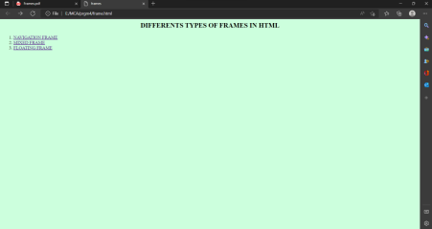

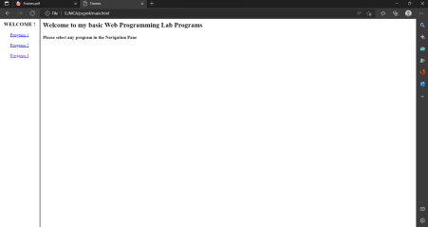



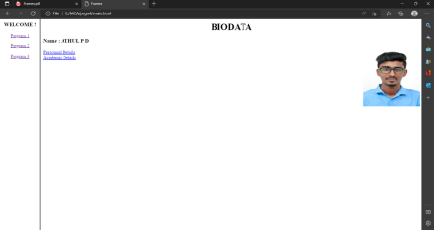

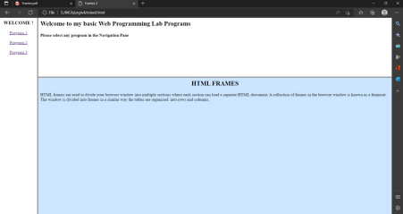

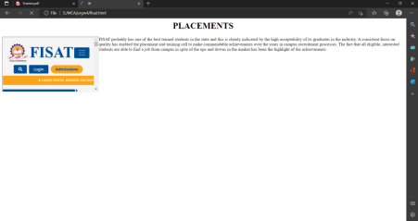

**AIM**

Analyse CSS by applying the different styles using inline, external & internal style sheets in a HTML file.

**Program Code**

**Prgm5.html**

<html>

<head>

<title>CSS DEMO</title>

</head>

<body bgcolor="#ccffdd">

<h2 align="center">DIFFERENTS TYPES OF CSS IMPLEMENTATION IN HTML</h2>

<ol>

<li><a href="inline.html">INLINE CSS</a></li>

<li><a href="internal.html">INTERNAL CSS</a></li>

<li><a href="external.html">EXTERNAL CSS</a></li>

</body>

</html>

**inline.html**

**<**html>

<head>

<title>INLINE CSS</title>

</head>

<body>

<h1 style="color:blue;">INLINE CSS</h1>

<p style="color:red;">An inline CSS is used to apply a unique style to a single HTML element.<br>

                      An inline CSS uses the style attribute of an HTML element.</p>

</body>

</html>

**internal.html**

<html>

<head>

<title>INTERNAL CSS</title>

<style>

body {background-color: DarkSlateGrey;}

h1   {color: FireBrick;}

p    {color: FloralWhite;}

</style>

</head>

<body>

<h1> INTERNAL CSS</h1>

<p>An internal CSS is used to define a style for a single HTML page.<br>

    An internal CSS is defined in the HEAD tag section of an HTML page, within a STYLE tag element.</p>

</body>

</html>

**External.html**

<html>

<head>

<title>EXTERNAL CSS</title>

 <link rel="stylesheet" href="stylish.css">

</head>

<body>

<h1>EXTERNAL CSS</h1>

<p> An external style sheet is used to define the style for many HTML pages.<br>

    To use an external style sheet, add a link to it in the Head tag section of each HTML page</p>

</body>

</html>

**stylish.css**

**body{**

background-color : Khaki;

}

h1{

color:IndianRed;

Font-size:24px;

}

p{

color:LightSeaGreen;

Font-size:24px;

}

**Output**

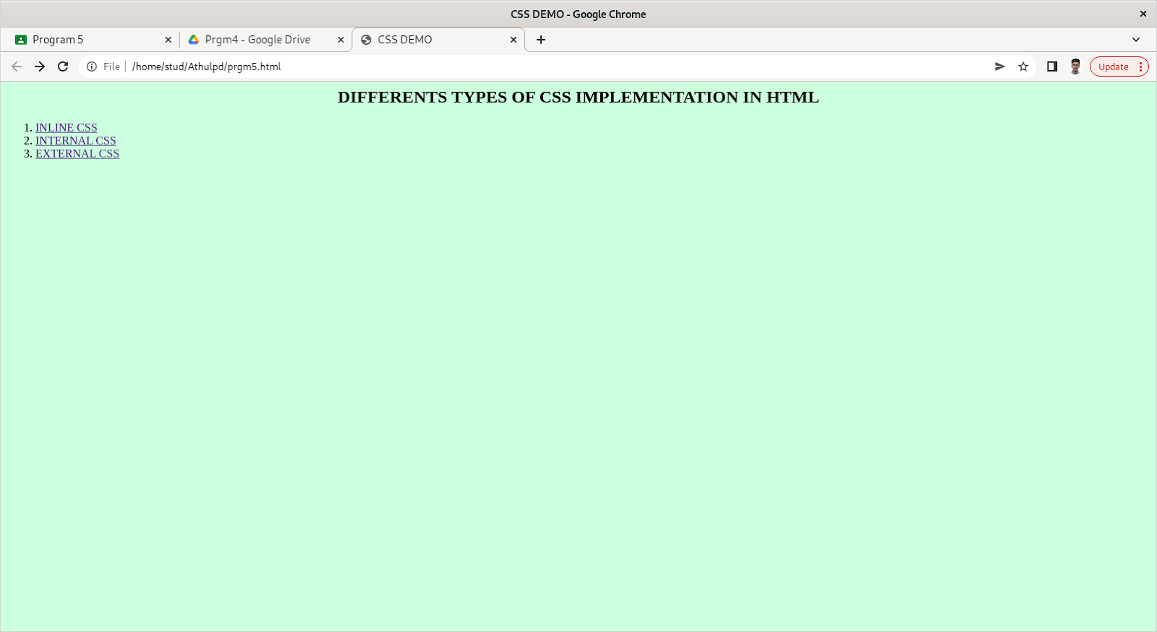

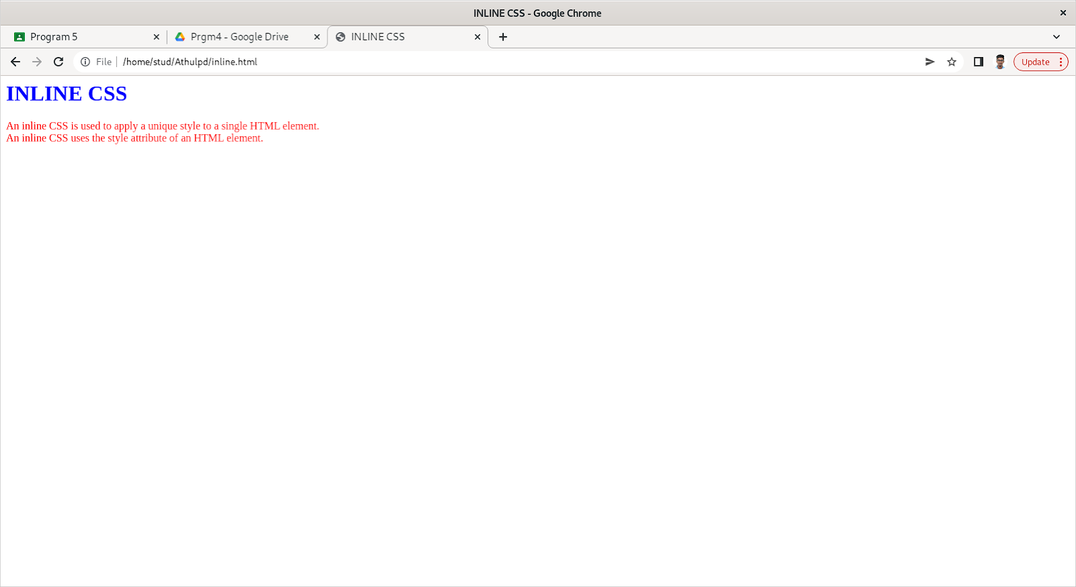

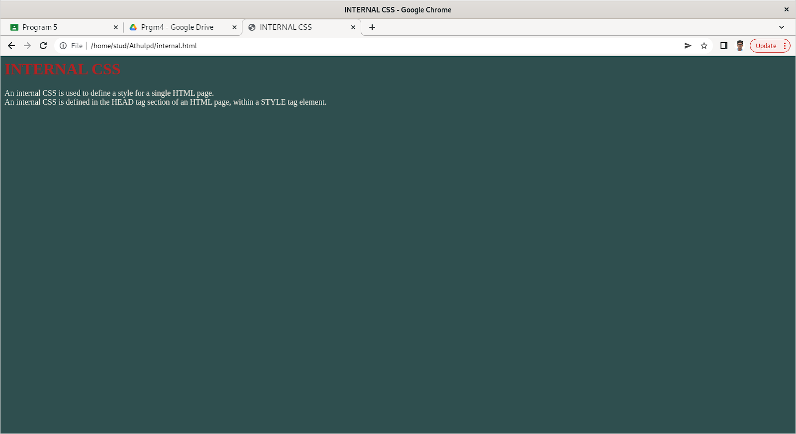

**AIM**

Create a HTML registration form and to validate the form using JavaScript code.

**Program Code**

**Validation html**

<html>

<head>

<title>Validation

</title>

<style>

.myDiv {

   width: 700px;

   height: 600px;

   position: absolute;

   top: 5%;

   left: 30%;

   background-color: #fefbd9;

   text-align: center;

   border-style: groove;

   border-color: #92a8d1;

}

</style>

<script>

function validateForm() {

var x = document.forms["myForm"]["fname"].value;

var y = document.forms["myForm"]["mob"].value;

if (x == "")

{

alert("Name must be filled out");

return false;

}

if(y== "")

{

alert("Mobile No must be filled out");

return false;

}

var n = document.forms["myForm"]["mob"].value;

if (isNaN(n)) {

alert("Mobile number must be digits only");

return false;

}

var j = document.forms["myForm"]["Gend"].value;

if (j == "")

{

alert("Gender must be selected");

return false;

}

}

</script>

</head>

<body background="C:\Users\anexp\Downloads\pgrm3-form-20221103T185956Z-001\pgrm3-form\back.jpg">

<div class="myDiv">

<br><br><h1><u>USER&nbsp;&nbsp;REGISTRATION&nbsp;&nbsp;-&nbsp;&nbsp;2022</u></h1><br>

<form name="myForm" method="post" onsubmit="return validateForm()">

Name: <input type="text" placeholder="Name of the student" name="fname"><br><br><br>

Gender: Male <input type="radio" placeholder="Gender of the student" name="Gend">

Female <input type="radio" placeholder="Gender of the student" name="Gend"><br><br><br>

Date of Birth: <input type="text" placeholder="DOB of student" name="dob"><br><br><br>

Mobile Number: <input type="text" placeholder="Phone no of the student" name="mob"><br><br><br>

Parent mobile Number: <input type="text" placeholder="Phone no of the Parent" name="mob2"><br><br><br>

Email Id: <input type="email" pattern=".+@gmail\.com" placeholder="Email id of the student" name="email"><br><br><br>

<button type="submit" style="height:50px; width:100px" value="Submit">Submit</button>

<button type="reset" value="Reset" style="height:50px; width:100px">Reset</button>

</form>

</div>

</body>

</html>

**Success.html**

<html>

<head>

<title>Success

</title>

<style>

.myDiv {

   width: 700px;

   height: 700px;

   position: absolute;

   top: 5%;

   left: 30%;

   background-color: #fefbd9;

 text-align: center;

border-style: groove;

 border-color: #92a8d1;

}

</style>

</head>

<body background="C:\Users\anexp\Downloads\pgrm3-form-20221103T185956Z-001\pgrm3-form\back.jpg">

<div class="myDiv">

<br><br><h1><u>USER&nbsp;&nbsp;REGISTRATION&nbsp;&nbsp;DETAILS&nbsp;&nbsp;SAVED</u></h1><br>

</div>

</body>

</html>

**Output**

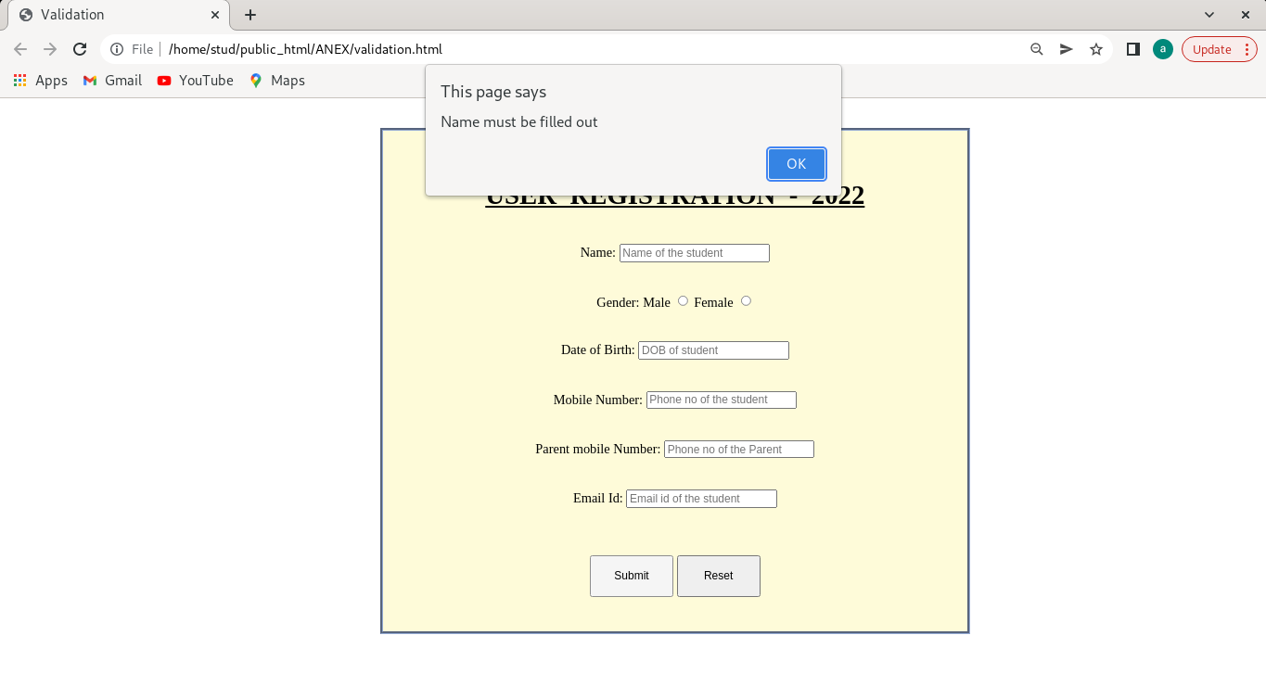

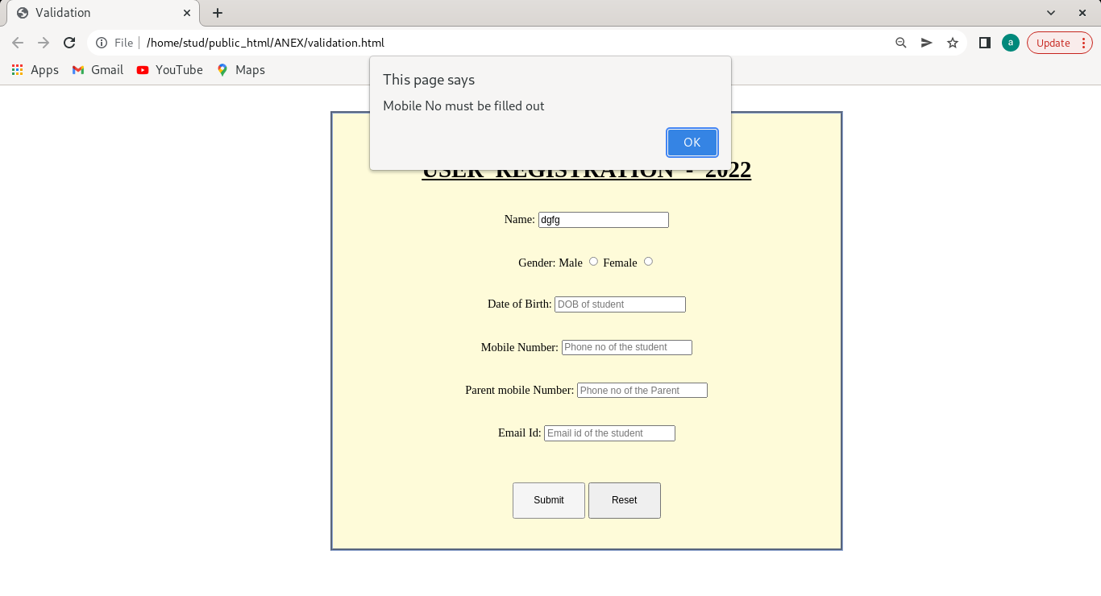

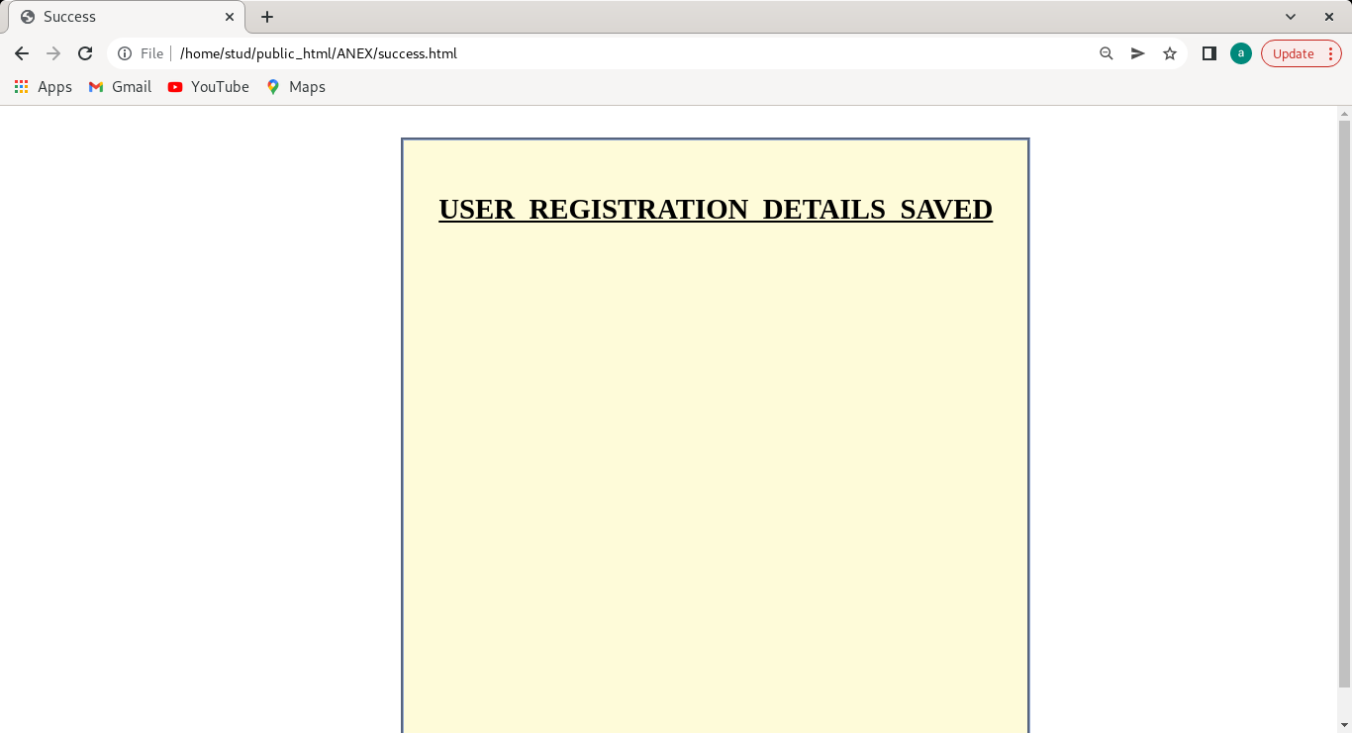

**AIM**

Create a HTML page to explain the use of various predefined functions in a string and math object in java script.

**Program Code**

<html>

<head>

<title>

</title>

<style>

.myDiv {

   width: 500px;

   height: 700px;

   position: absolute;

   top: 5%;

   left: 15%;

   background-color: #fffbc9;

   text-align: center;

   border-style: groove;

   border-color: #92a8d1;

}

.myDiv1 {

   width: 500px;

   height: 1000px;

   position: absolute;

   top: 5%;

   left: 50%;

   background-color: #fffbc9;

   text-align: center;

   border-style: groove;

  border-color: #92a8d1;

}

</style>

</head>

<body>

<div class="myDiv">

<br><br><h2><u>STRING&nbsp;&nbsp;FUNCTIONS</u></h2><br>

Enter a string <br><br><input type="text" name="fname" id="text1">

<br><br>

<button type="submit" style="height:50px; width:100px" value="Submit" onclick="StringForm()">Submit</button>

<br><br>

<u>Output</u><br>

<p id="text2">

</p>

<p id="text3">

</p>

<p id="text4">

</p>

<p id="text5">

</p>

<p id="text6">

</p>

<p id="text7">

</p>

<p id="text8">

</p>

<p id="text9">

</p>

<p id="text10">

</p>

<p id="text11">

</p>

<p id="text12">

</p>

</div>

<div class="myDiv1">

<br><br><h2><u>MATH&nbsp;&nbsp;FUNCTIONS</u></h2><br>

Enter any digit<br><br><input type="number" id="qu" name="quantity">

<br><br>

<button type="submit" style="height:50px; width:100px" value="Submit" onclick="MathForm()">Submit</button>

<br><br>

<u>Output</u><br><br>

<u>Constants</u><br>

<p id="texta">

</p>

<br><br>

<p id="textb">

</p>

<p id="textc">

</p>

<p id="textd">

</p>

<p id="texte">

</p>

<p id="textf">

</p>

<p id="textg">

</p>

<p id="texth">

</p>

<p id="texti">

</p>

<p id="textj">

</p>

<p id="textk">

</p>

<p id="textl">

</p>

<p id="textm">

</p>

</div>

</body>

<script>

function StringForm() {

let text = document.getElementById("text1").value;

let length = text.length;

let part = text.slice(3,5);

let sub = text.substring(4,6);

let subs = text.substr(-1);

let re = text.replace("anex","pauly");

let rep = text.replaceAll("m","M");

let up = text.toUpperCase();

let lo = text.toLowerCase();

let co = text.concat("","pauly");

let tr = text.trim();

let ch = text.charAt(2);

document.getElementById("text2").innerHTML = "The String Length is : " + length;

document.getElementById("text3").innerHTML = "The Sliced String from 3rd to 5th position is : " + part;

document.getElementById("text4").innerHTML = "The Sub String from 4th to 6th position is : " + sub;

document.getElementById("text5").innerHTML = "The Subpart of the String is : " + subs;

document.getElementById("text6").innerHTML = "The replaced String is : " + re;

document.getElementById("text7").innerHTML = "The replaceAll String is : " + rep;

document.getElementById("text8").innerHTML = "The Uppercased String is : " + up;

document.getElementById("text9").innerHTML = "The Lowercased String is : " + lo;

document.getElementById("text10").innerHTML = "The concated String is : " + co;

document.getElementById("text11").innerHTML = "The Trimed String is : " + tr;

document.getElementById("text12").innerHTML = "The Character at 2nd position of the String is : " + ch;

return true;

}

function MathForm() {

let text = document.getElementById("qu").value;

let ro = Math.round(text);

let ce = Math.ceil(text);

let fl = Math.floor(text);

let tu = Math.trunc(text);

let si = Math.sign(text);

let po = Math.pow(text,2);

let sq = Math.sqrt(text);

let ab = Math.abs(text);

let sin = Math.sin(text * Math.PI / 180);

let cos = Math.cos(text * Math.PI / 180);

let min = Math.min(0, 150, 30, 20, -8, -200);

let max = Math.max(0, 150, 30, 20, -8, -200);

let ra = Math.random();

let l = Math.log(text);

document.getElementById("texta").innerHTML = "<p><b>Math.E:</b> " + Math.E + "</p>" +

"<p><b>Math.PI:</b> " + Math.PI + "</p>" +

"<p><b>Math.LN10:</b> " + Math.LN10 + "</p>" +

"<p><b>Math.LOG2E:</b> " + Math.LOG2E + "</p>"

document.getElementById("textb").innerHTML = "The Rounded value is " + ro;

document.getElementById("textc").innerHTML = "The Rounded value using ceil function is " + ce;

document.getElementById("textd").innerHTML = "The Rounded value using floor function is " + fl;

document.getElementById("texte").innerHTML = "The Rounded value using truncate function is " + tu;

document.getElementById("textf").innerHTML = "The sign of the value is " + si;

document.getElementById("textg").innerHTML = "The power of the value with 2 is " + po;

document.getElementById("texth").innerHTML = "The sin value for the angle given is " + sin;

document.getElementById("texti").innerHTML = "The cos value for the angle given is " + cos;

document.getElementById("textj").innerHTML = "The min value for the given values(0,150,30,20,-8,-200) is " + min;

document.getElementById("textk").innerHTML = "The max value for the given values(0,150,30,20,-8,-200) is " + max;

document.getElementById("textl").innerHTML = "The random value between 0 and 1 is " + ra;

document.getElementById("textm").innerHTML = "The log value for the given number is " + l;

return true;

}

</script>

</html>

**Output**

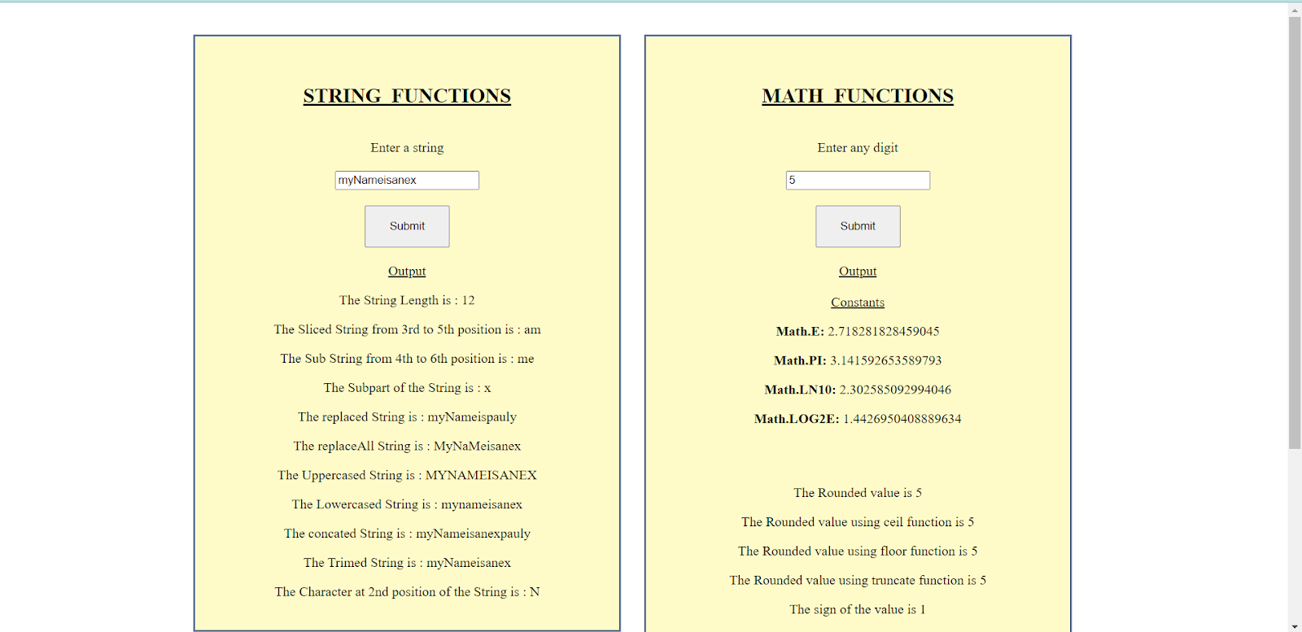

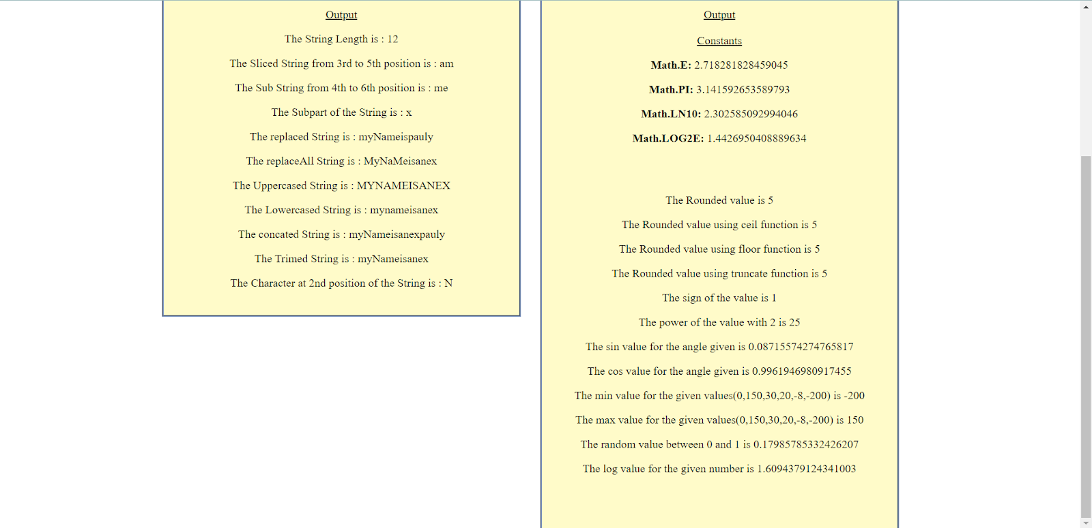

**AIM**

Create a HTML page to change the background color for every click of a button using JavaScript Event Handling.

**Program Code**

<html>

<head>

<title>

changing the background color

</title>

</head>

<body style = "text-align:center;">

<h1 style = "color:blue;" >

Welcome

</h1>

<button type="button" id="color-button" onclick="changeBg()">Click Here

</button>

<br>

<script>

document.writeln( "Click on button to change the background color");

const pageBody = document.querySelector("body");

function changeBg()

{

let color = '#'+(Math.random()*0xFFFFFF<<0).toString(16);

pageBody.style.background = color;

}

</script>

</body>

</html>

**Output**

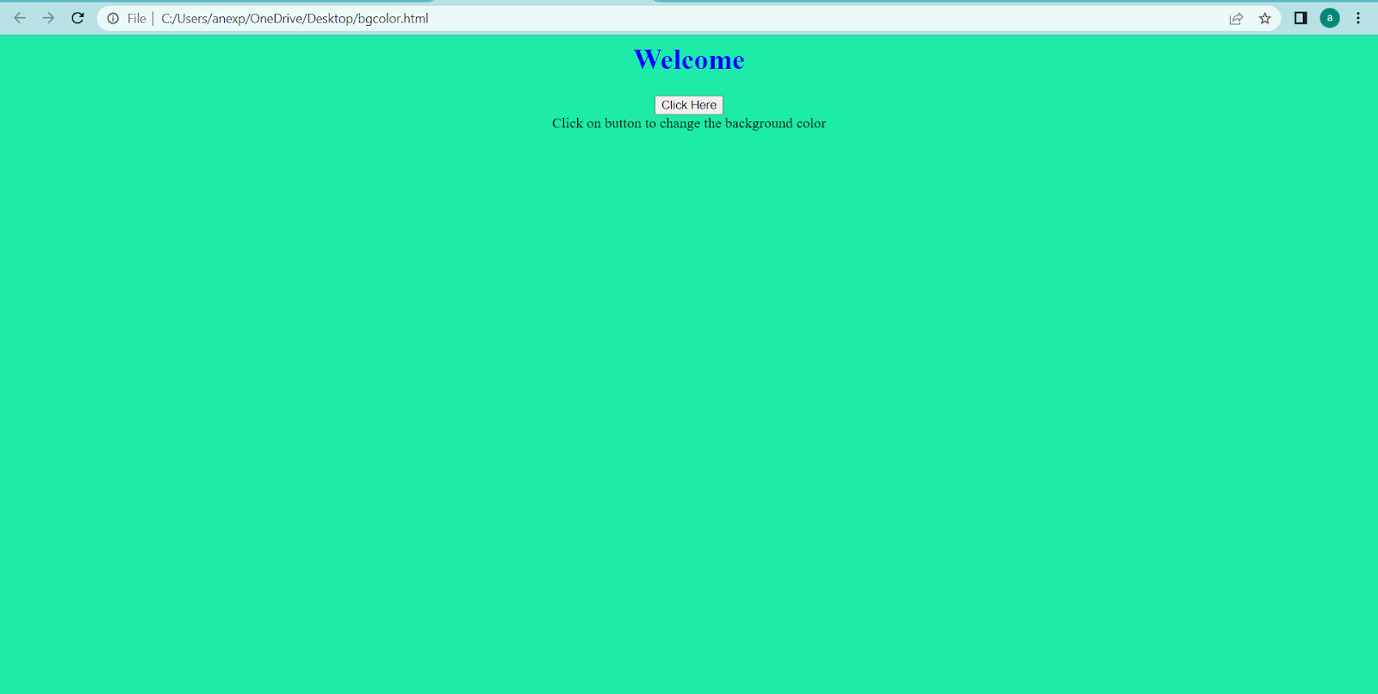

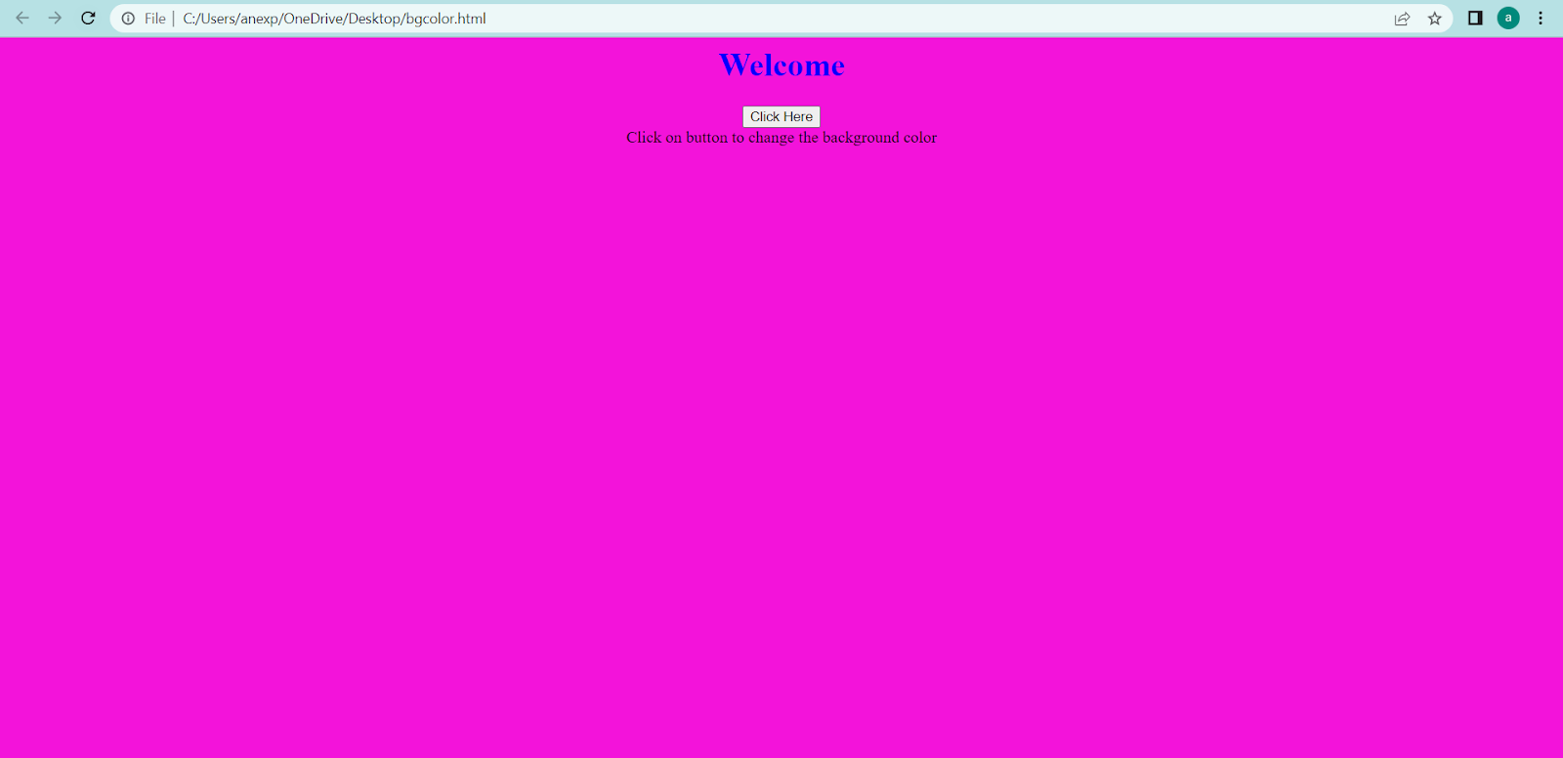

**AIM**

Compose Electricity bill from user input based on a given tariff using PHP.

**Program Code**

<html>

<head><title>Electricity Bill</title></head>

<body><hr><center><br><br><h1><b>ELECTRICITY BILL</b></h1><hr>

<form method="post"><b>

Name : <input type="text" id="name" name="name"

required="required" placeholder="Enter your name"><br><br>

Units: <input type="text" id="units" name="units"

required="required" placeholder="Enter the Units"><br><br>

<input type="submit" value="Generate Bill" name="submit"><br>

</form>

</b>

<?php

if (isset($_POST['submit']))

{

$n=$_POST["name"];

$u=$_POST["units"];

if(!empty($u)){

$result = bill($u);

echo "<b>Name:</b>",$n,"<br><br>";

echo "<b>Units: </b>",$u,"<br><br>";

echo '<b>Total amount</b> ' . $result.'Rs';

}

}

function bill($units) {

$first = 2;

$second=3;

$third =4;

if($units <= 100) {

$bill = $units * $first;

}

else if($units > 100 && $units <= 200) {

$temp = 100 * $first;

$remaining_units = $units - 100;

$bill = $temp + ($remaining_units * $second);

}

else {

$temp = 100 * $first;

$temp2=100 * $second;

$remaining_units = $units - 200;

$bill =$temp + $temp2 + ($remaining_units * $third);

}

return number_format((float)$bill, 2, '.', '');

}

?>

</center>

</body></html>

**Output**

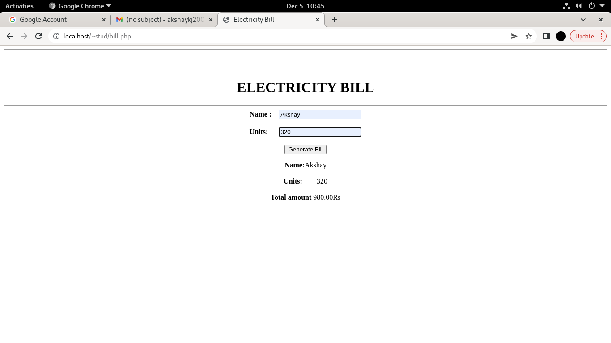

**AIM**

Build a PHP code to store name of students in an array and display it using print_r  
function. Sort and Display the same using asort & arsort functions.

**Program Code**

<html>

<head><title>Student Name</title></head>

<body>

<h1>Student Registration </h1>

<hr>

<form method="post" name="form1"><b>

Student 1 :<input type="text" name="stud1" required="required" placeholder="Enter

name of 1st Student"><br><br>

Student 2 :<input type="text" name="stud2" required="required" placeholder="Enter

name of 2nd Student"><br><br>

Student 3 :<input type="text" name="stud3" required="required" placeholder="Enter

name of 3rd Student"><br><br>

Student 4 :<input type="text" name="stud4" required="required" placeholder="Enter

name of 4th Student"><br><br>

Student 5 :<input type="text" name="stud5" required="required" placeholder="Enter

name of 5thStudent"><br><br>

<input type="submit" name="submit" value="Enter"></b>

<input type="reset" value="reset"></b>

<br><hr>

</form>

<?php

$s[0]=$_POST["stud1"];

$s[1]=$_POST["stud2"];

$s[2]=$_POST["stud3"];

$s[3]=$_POST["stud4"];

$s[4]=$_POST["stud5"];

?>

<center>

<h1><u>Students List</h1></u><br>

<h3><i><u>Display using </i> "print_r"</u> -<?php

print_r($s); ?></h3><br><br>

<h3><i><u>Display using </i> "asort()"</u> -

<?php asort($s);

foreach($s as $value){

echo $value . " ";}

?>

</h3><br><br>

<h3><i><u>Display using </i> "arsort()"</u> -

<?php arsort($s);

foreach($s as $value){

echo $value . " ";}

?>

</h3><br><br>

</center>

</body>

</html>

**Output**

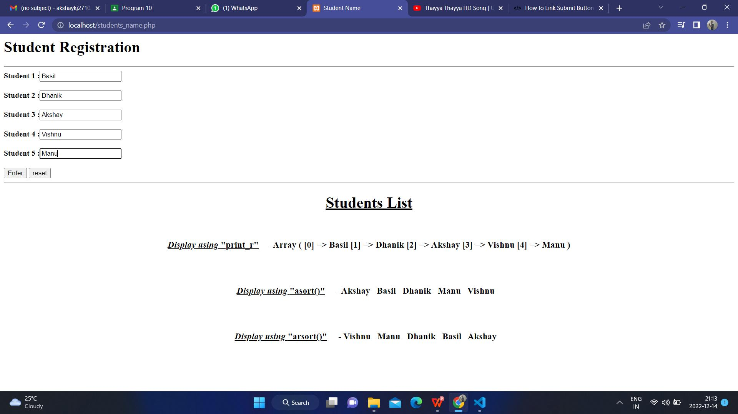

**AIM**

Build a PHP code to store name of Indian Cricket players in an array and display  
the same in HTML table.

**Program Code**

<html>

<head>

<title>cricket players names</title>

</head>

<body bgcolor="#bc9cdb">

<center><br><br><br><br>

<form method="post" action="cricketplayers.php">

<i><h1> Indian Cricket Players</h1><b></i>

Name 1: <input type="text" name="name1" id="name1"><br><br>

Name 2: <input type="text" name="name2" id="name2"><br><br>

Name 3: <input type="text" name="name3" id="name3"><br><br>

Name 4 :<input type="text" name="name4" id="name4"><br><br>

Name 5 :<input type="text" name="name5" id="name5"><br><br>

<input type="submit" name="submit" id="submit"></b>

<input type="Reset" name="submit" id="Reset">

</center>

</form>

</body>

</html>

**cricketplayers.php**

<html>

<table border='1' align='center' style="width:20%; breadth= 20%;" callspan='20' cellpadding='10'>

<?php

if (isset($_POST['submit']))

{

$name [0]= $_POST['name1'];

$name [1]= $_POST['name2'];

$name [2]= $_POST['name3'];

$name [3]= $_POST['name4'];

$name [4]= $_POST['name5'];

echo "";

echo "<hr><h1><b><u><center>CRICKET PLAYERS LIST</center</h1></u></b>";

echo "<tr> " ;

echo "<hr><td>1.</td><th><h2> $name[0]</h2></th>";

echo "</tr>";

echo "<tr>";

echo "<td>2.</td><th><h2> $name[1]</h2></th>";

echo "</tr>";

echo "<tr>";

echo "<td>3.</td><th><h2> $name[2]</h2></th>";

echo "</tr>";

echo "<tr> ";

echo "<td>4.</td><th><h2> $name[3]</h2></th>";

echo "</tr>";

echo "<tr>";

echo "<td>5.</td><th><h2> $name[4]</h2></th>";

echo "</tr>";

echo "</table>";

}

?>

</html>

**Output**

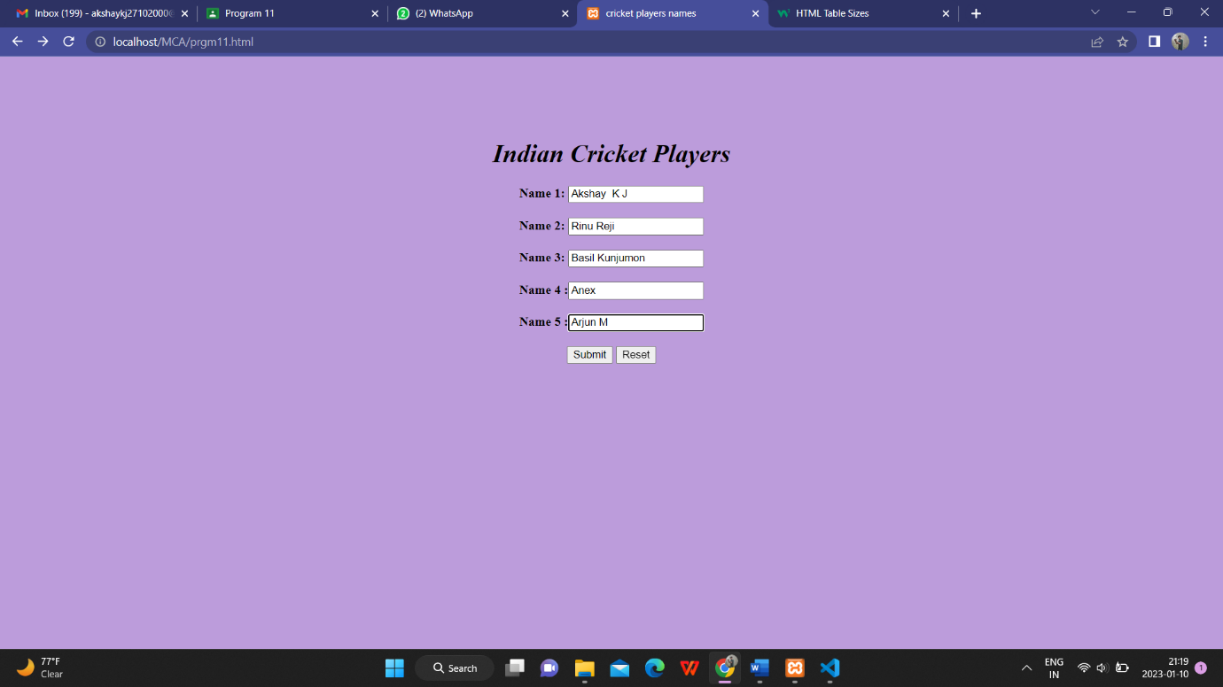

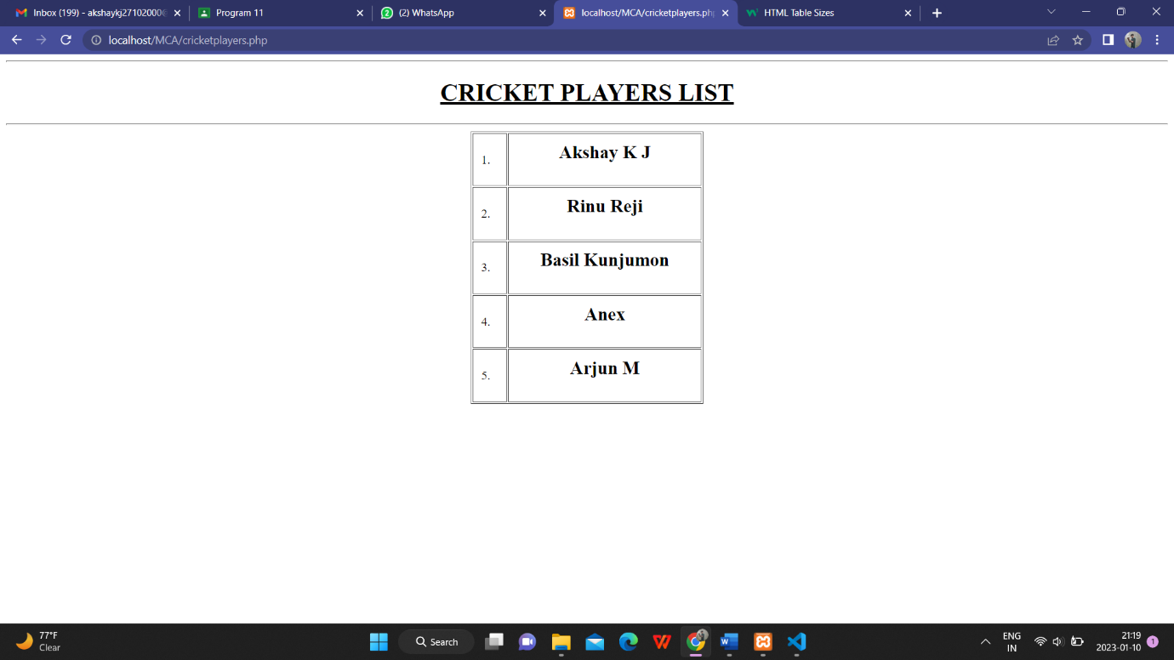

**AIM**

Outline a registration form using PHP and do necessary validations.

**Program Code**

<?php

$name = $email= $date= $address= $phone= $gender= "";

$name1= $email1= $date1= $address1= $phone1= $gender1= "";

if (isset($_POST["submit"]))

{

if (empty($_POST["fname"]))

{

$name = "Name is required";

}

else

{

$name1 = $_POST["fname"];

}

if (empty($_POST["email"]))

{

$email= "Email is required";

}

else

{

$email1= $_POST["email"];

}

if (empty($_POST["date"]))

{

$date = "Date is required";

}

else

{

$date1 = $_POST["date"];

}

if (empty($_POST["address"]))

{

$address = "Address is required";

}

else

{

$address1= $_POST["address"];

}

if (empty($_POST["gender"]))

{

$gender = "Gender is required";

}

else

{

$gender1 = $_POST["gender"];

}

if (empty($_POST["phone"]))

{

$phone= "phone is required";

}

else

{

$phone1 = $_POST["phone"];

}

}

?>

<html>

<head>

<style>

.error {color: red;}

td{

padding:15px;

}

</style>

</head>

<center>

<body bgcolor="#66bd99">

<table >

<form method="post" action="validationform.php">

<h1><b><u>Form Validation </h1></b></u><hr>

<tr>

<td style="font-size: 15px;font-family:sans-serif;font-weight: bold; text-shadow: 2px 1px gray;">

Name:<input type="text" name="fname" style="height:30px;width:250px;"></td>

<td><span class="error"><?php echo $name;?></span></td>

</tr>

<tr>

<td style="font-size: 15px;font-family:sans-serif;font-weight: bold; text-shadow: 2px 1px gray;">

Email :<input type="text" name="email" style="height:30px;width:250px;"></td>

<td><span class="error"><?php echo $email;?></span></td>

</tr>

<tr>

<td style="font-size: 15px;font-family:sans-serif;font-weight: bold; text-shadow: 2px 1px gray;">

Date of Birth :<input type="date" name="date" style="height:30px;width:250px;"></td>

<td><span class="error"><?php echo $date;?></span></td>

</tr>

<td style="font-size: 15px;font-family:sans-serif;font-weight: bold; text-shadow: 2px 1px gray;">

Gender : <input type="radio" name="gender" value="male">Male

<input type="radio" name="gender" value="female">Female</td>

<td><span class="error"><?php echo $gender;?></span></td>

</tr>

<tr>

<td style="font-size: 15px;font-family:sans-serif;font-weight: bold; text-shadow: 2px 1px gray;">

Phone : <input type="text" name="phone" style="height:30px;width:250px;"></td>

<td><span class="error"><?php echo $phone;?></span> </td>

</tr>

<tr>

<td style="font-size: 15px;font-family:sans-serif;font-weight: bold; text-shadow: 2px 1px gray;">

Address :<textarea rows="2" cols="20" name=address style="height:30px;width:250px;"></textarea></td>

<td><span class="error"><?php echo $address;?></span></td>

</tr>

<td><center><input type="submit" name="submit" value="submit">

<input type="Reset" name="Reset" value="Reset"></center></td></tr>

</table>

</form>

<?php

if(isset($_POST['submit'])) {

if($name == "" && $email== "" && $date== "" && $phone == "" && $gender== "" && $address == "")

{

echo "<h3 color=#FF0001> <b>You have sucessfully registered.</b> </h3>";

echo "<h2><u>Your Input:</h2></u>";

echo "<b>Name:</b> " .$name1;

echo "<br>";

echo "<b>Email:</b> " .$email1;

echo "<br>";

echo "<b>Date of birth:</b> " .$date1;

echo "<br>";

echo "<b>Phone No:</b> " .$phone1;

echo "<br>";

echo "<b>Address:</b> " .$address1;

echo "<br>";

echo "<b>Gender: </b>" .$gender1;

}

else

{

echo "<h3><b>You didn't filled up the form completely.</b> </h3>";

}

}

?>

</body>

</html>

**Output**

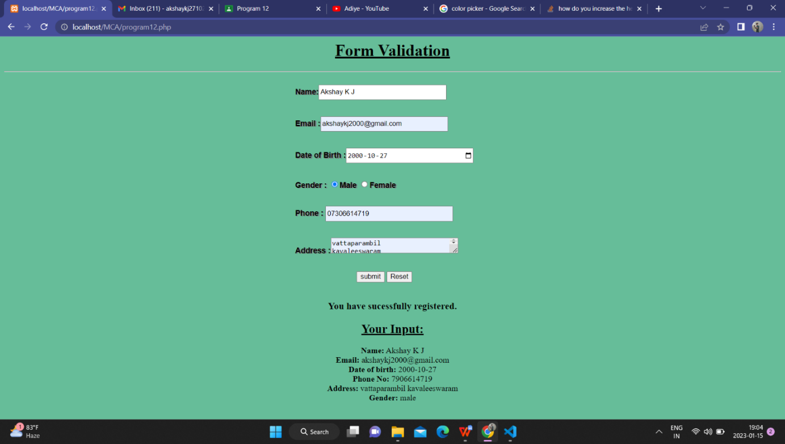

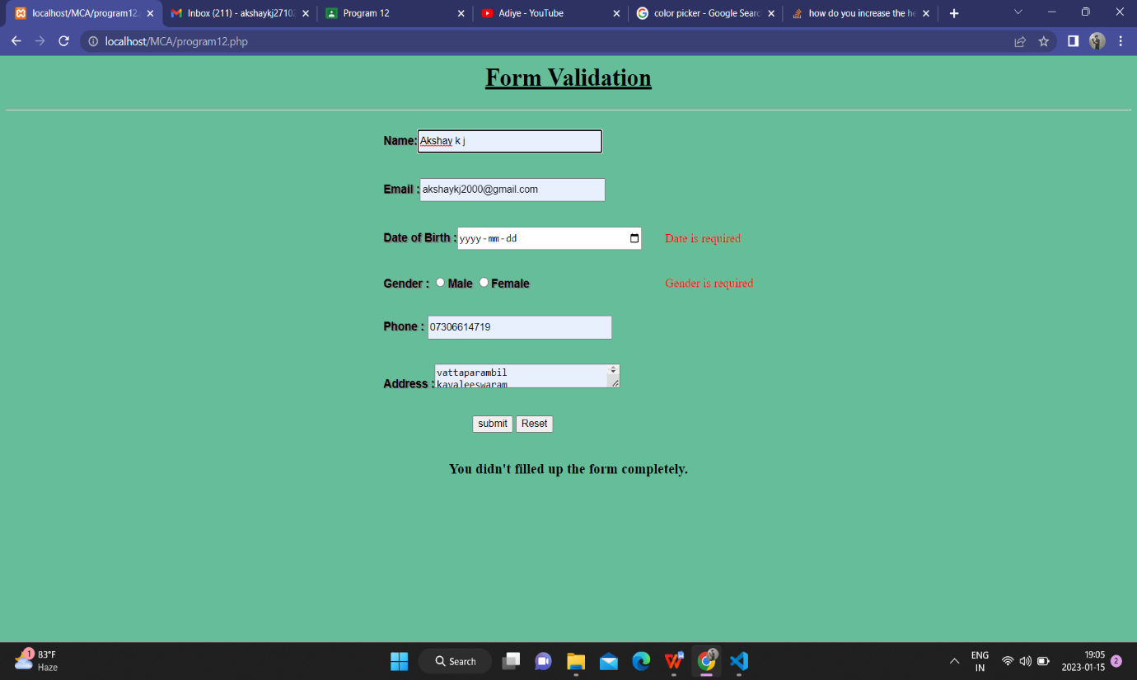

**AIM**

Develop a PHP program to connect to a database and add data to the employee table and retrieve data from the table and show the retrieved details in a neat format.

**Program Code**

**html.php**

<html>

<head>

<title>Employee Registration</title>

</head>

<body align="center">

<h1>Employee Registration</h1>

<form name="reg" method="POST" action="p.php">

<button >Register</button>

</form>

<br>

<form method="POST" action="p1.php">

<button >View</button>

</form>

</body>

</html>

**p.php**

<html>

<head>

<title>Employee Registration</title>

</head>

<body>

<fieldset>

<center>

<h1>Employee Registration</h1>

<form name="eform" method="post" action="con.php">

<table>

<tr>

<td>Employee ID :</td><td>

<input type="number" name="eid" id="eid"></td>

</tr>

<td>Employee Name :</td>

<td><input type="text" name="ename" id="ename"></td>

</tr>

<td>Department :</td>

<td><input type="text" name="edp" id="edp"></td>

</tr>

<td>Age :</td>

<td><input type="number" name="eage" id="eage"></td>

</tr>

</table>

<p>&nbsp;</p>

<p>

<input type="submit" name="Submit" id="Submit" value="Submit">

</p>

</form>

</fieldset>

</center>

</body>

</html>

con.php

<?php

$con = new mysqli('localhost', 'fisat', 'fisat','fisatdb');

$id = $_POST['eid'];

$name = $_POST['ename'];

$dept = $_POST['edp'];

$age = $_POST['eage'];

$sql = "INSERT INTO employee(EmpID,EmpName,Department,Age) VALUES($id, '$name', '$dept', $age)";

$rs = mysqli_query($con, $sql);

if($rs)

{

echo "Contact Records Inserted";

}

else

{

echo "Error : could not execute query : $sql".$con->error;

}

?>

< html>

<head>

<title></title>

</head>

<body align="center">

<form name="gb" method="POST" action="html.php">

<button >Go Back!</button>

</form>

</body>

</html>

p1.php

<?php

$con = new mysqli("localhost", "fisat", "fisat", "fisatdb");

if ($con=== false)

{

die("ERROR: Could not connect. " . mysqli_connect_error());

}

$sql = "SELECT * FROM employee";

if ($result = $con->query($sql))

{

if ($result->num_rows > 0)

{

?>

<html>

<body>

<center>

<table border=1>

<tr>

<th>Employee ID</th><th>Employee Name</th><th>Employee Department</th><th>Employee Age</th>

</tr>

<tr>

<?php while($row = $result->fetch_array()) { ?>

<td><?php echo $row[0]; ?> </td><td><?php echo $row[1];?></td><td><?php echo $row[2];?></td><td><?php echo $row[3];?></td>

</tr>

<?php

}

?>

</table>

</center>

</html>

<?php

$result->close();

}

else

{

echo "No records matching your query were found.";

}

}

else

{

echo "ERROR: Could not execute $sql. " . $con->error;

}

$con->close();

?>

**Output**

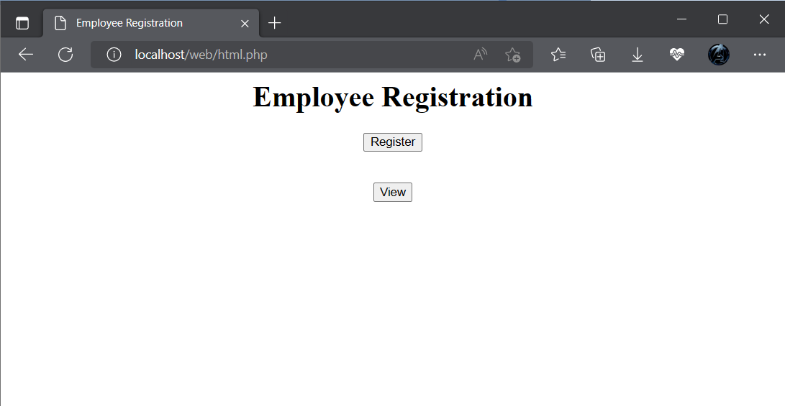

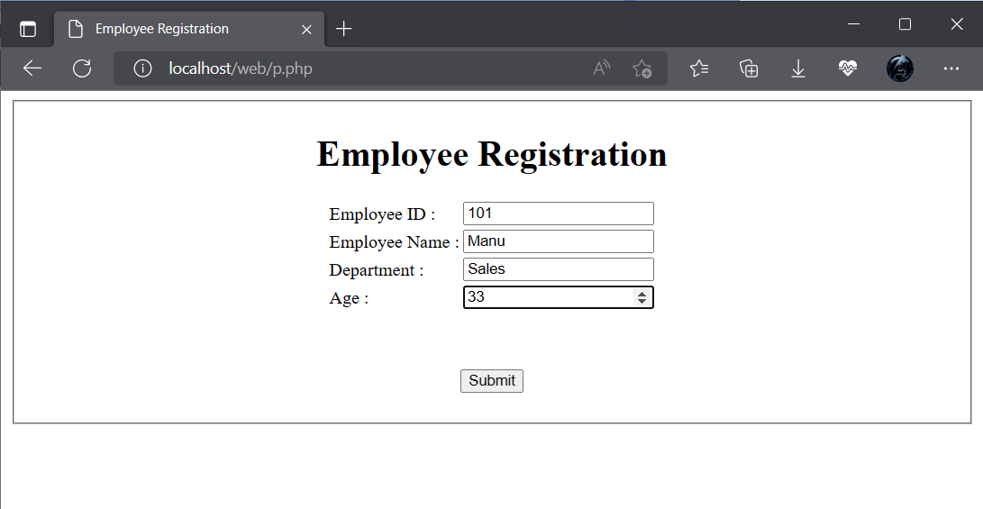

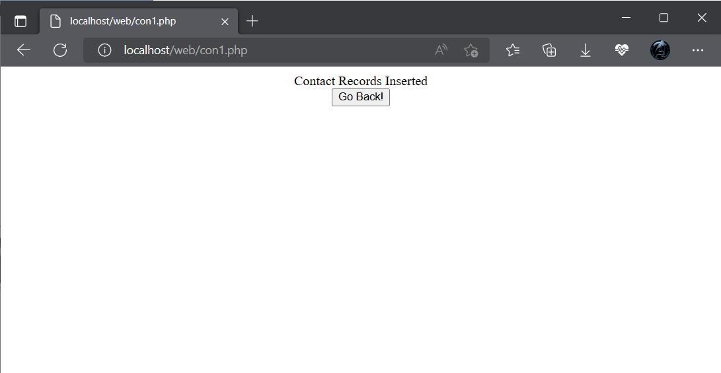

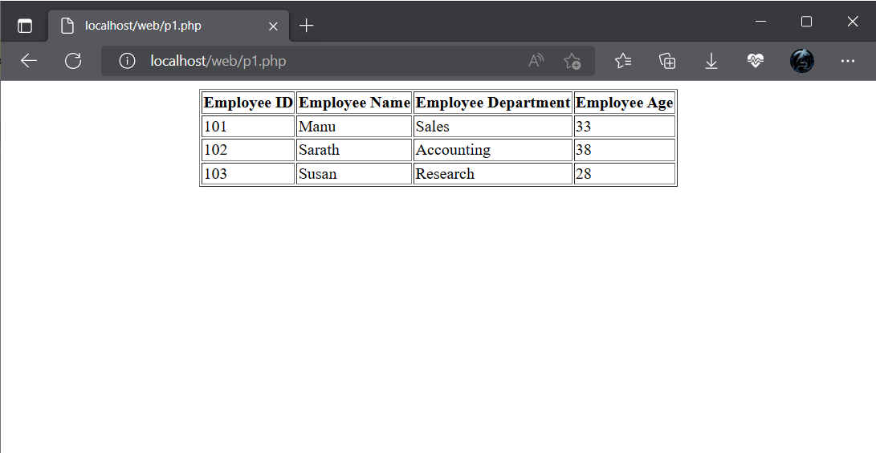

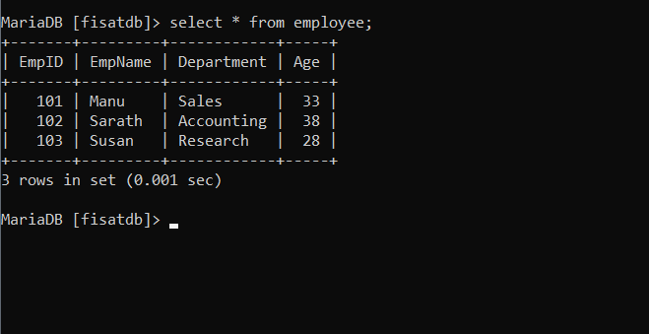

**AIM**

Using PHP and MySQL, develop a program to accept book information viz. Accession number, title, authors, edition and publisher from a web page and store the information in a database and to search for a book with the title specified by the user and to display the search results with proper headings.

**Program Code**

**html.php**

<html>

<head>

<title>Book Information</title>

</head>

<body align="center">

<h1>Book Information Registration</h1>

<form name="reg" method="POST" action="p.php">

<button >Register</button>

</form>

<br>

<form method="POST" action="p2.php">

<button >search</button>

</form>

</body>

</html>

**p.php**

<html>

<head>

<title>Book Information Registration</title>

</head>

<body>

<fieldset>

<center>

<h1>Book Information Registration</h1>

<form name="eform" method="post" action="con.php">

<table>

<tr>

<td>Accession number:</td><td>

<input type="number" name="accession" id="accession"></td>

</tr>

<td>Title:</td>

<td><input type="text" name="title" id="title"></td>

</tr>

<td>Author:</td>

<td><input type="text" name="author" id="author"></td>

</tr>

<td>Edition:</td>

<td><input type="number" name="edition" id="edition"></td>

</tr>

<td>Publisher:</td>

<td><input type="text" name="pub" id="pub"></td>

</tr>

</table>

<p>&nbsp;</p>

<p>

<input type="submit" name="Submit" id="Submit" value="Submit">

</p>

</form>

</fieldset>

</center>

</body>

</html>

**p2.php**

<html>

<body align="center">

<form action="p1.php" method="post">

Search <input type="text" name="search"><br>

<input type ="submit">

</form>

</body>

</html>

**con.php**

<?php

$con = new mysqli('localhost', 'fisat', 'fisat','fisatdb');

$acc = $_POST['accession'];

$title = $_POST['title'];

$author = $_POST['author'];

$edition = $_POST['edition'];

$pub = $_POST['pub'];

$sql = "INSERT INTO Bookinfo(AccessionNumber,Title,Author,Edition,Publisher) VALUES('$acc', '$title', '$author', '$edition', '$pub')";

$rs = mysqli_query($con, $sql);

if($rs)

{

echo "Contact Records Inserted";

}

else

{

echo "Error : could not execute query : $sql".$con->error;

}

?>

<html>

<head>

<title></title>

</head>

<body align="center">

<form name="gb" method="POST" action="html.php">

<button >Go Back!</button>

</form>

</body>

</html>

**p1.php**

<?php

$con = new mysqli("localhost", "fisat", "fisat", "fisatdb");

if ($con=== false) {

die("ERROR: Could not connect. " . mysqli_connect_error());

}

$search = $_POST['search'];

$sql = "select * from Bookinfo where author like '%$search%'";

if ($result = $con->query($sql))

{ if ($result->num_rows > 0) {

?>

<html>

<body>

<center>

<table border=1>

<tr>

<th>Accession Number</th><th>Title</th><th>Author</th><th>Edition</th><th>Publisher</th>

</tr>

<tr>

<?php while($row = $result->fetch_array()) { ?>

<td><?php echo $row[0]; ?> </td>

<td><?php echo $row[1];?></td>

<td><?php echo $row[2];?></td>

<td><?php echo $row[3];?></td>

<td><?php echo $row[4];?></td>

</tr>

<?php

} ?>

</table>

</center>

</html>

<?php

$result->close();

} else {

echo "No records matching your query were found.";

}

} else {

echo "ERROR: Could not execute $sql. " . $con->error;

} $con->close();

?>

**Output**

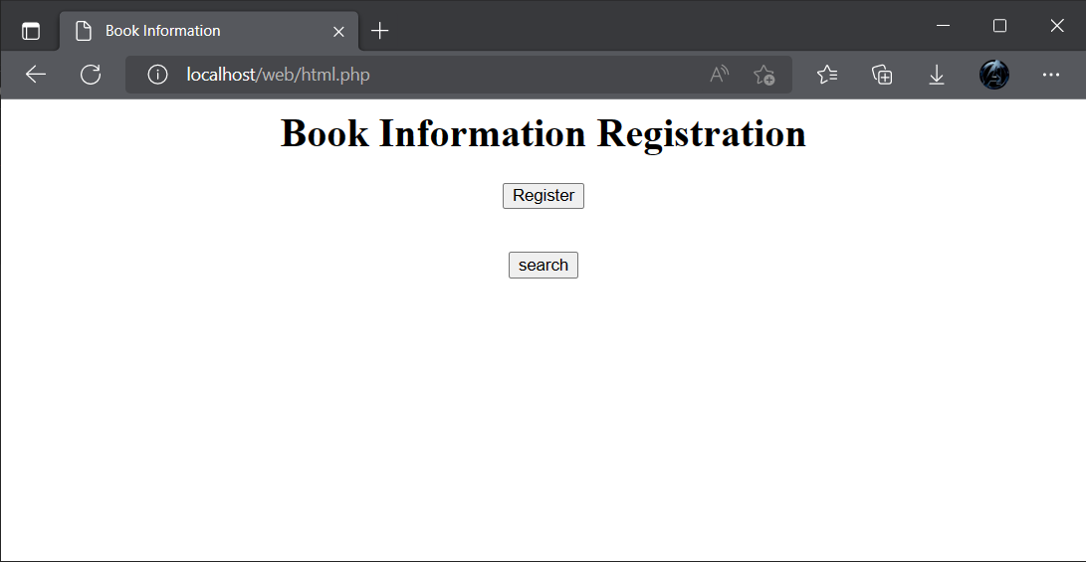

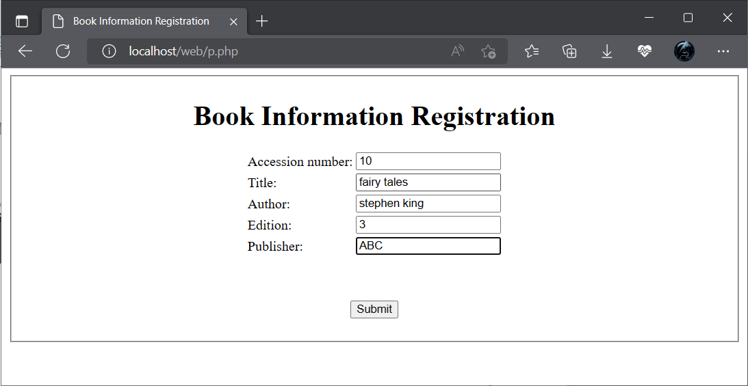



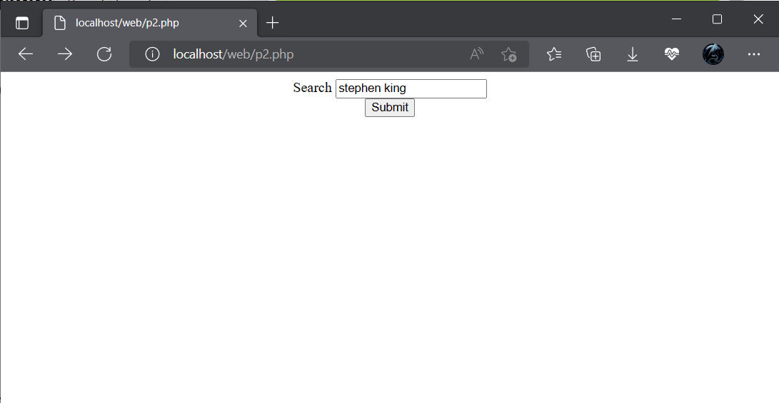

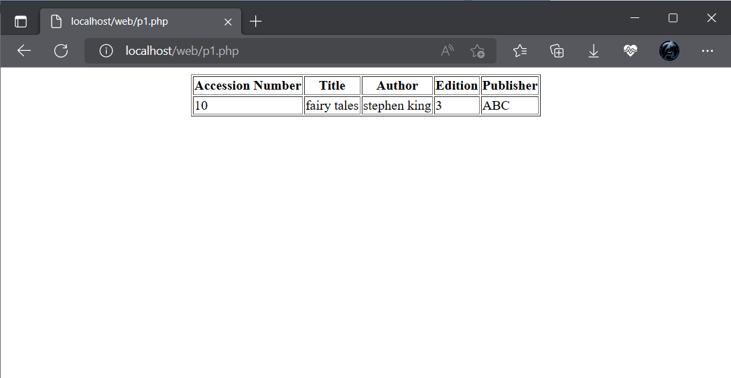

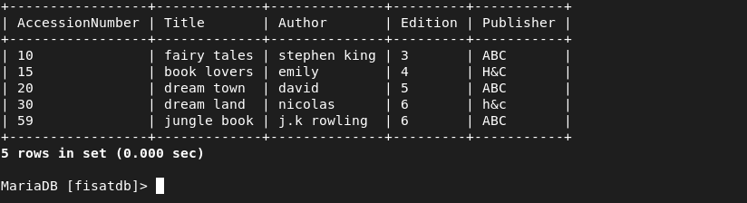

**AIM**

Using PHP and MySQL, develop a program to collect airline details and display all the airlines between a particular source and destination.

**Program Code**

**airlineinfo.html**

<html>

<head>

<title>airline</title>

<style>

body{

background-color:Lavender;

text-align:center;

}

</style>

</head>

<body><u>AIRLINE INFORMATION SYSTEM</u><br><br>

<a href="add_airlineinfo.html">Add AIRLINE DETAILS</a><br><br>

<a href="search1.html">Search AIRLINE DETAILS</a><br>

</body>

</html>

**add_airlineinfo.html**

<html>

<head>

<style>

td{

padding:15px;

}

body{

background-color:Lavender;

text-align:center;

}

</style>

</head>

<form name="frm2" method="post" action="addair.php">

<h1>Enter Airline Details</h1>

<table border="1" align="center">

<tr>

<td>AIRLINE ID:</td>

<td><input type="number" name="id"></td>

</tr>

<tr>

<td>AIRLINE NAME:</td>

<td><input type="text" name="name"></td>

</tr>

<tr>

<td>DEPARTURE FROM:</td>

<td> <input type="text" name="depfrom"></td>

</tr>

<tr>

<td>DEPARTURE TIME:</td>

<td><input type="number" name="deptime"></td>

</tr>

<tr>

<td>AIRRIVAL TIME:</td>

<td><input type="number" name="aritime"></td>

</tr>

<tr>

<td>AIRRIVAL PLACE:</td>

<td><input type="text" name="ariplace"></td>

</tr>

<tr>

<td> <input type="submit" name="submit" value="submit"></td>

<td><input type="reset" name="reset" value="reset"></td></tr>

</table>

</form>

</body>

</html>

**addair.php**

<?php

$id=$_POST['id'];

$name=$_POST['name'];

$depfrom=$_POST['depfrom'];

$deptime=$_POST['deptime'];

$airtime=$_POST['aritime'];

$airplace=$_POST['ariplace'];

$con=new mysqli("localhost","fisat","fisat","fisatdb");

if($con==false)

{

echo "Failed to connect";

}

else

{

echo "connected";

}

$sql="INSERT INTO airline VALUES($id,'$name','$depfrom',$deptime,$airtime,'$airplace')";

if($con->query($sql))

{

echo "<BR>";

echo 'New row added';

}

else

{

echo "ERROR:could not execute query";

}

$con->close();

?>

**search1.hml**

<html>

<head>

<title>search</title>

<style>

td

{

padding:15px;

}

body

{

background-color:Lavender;

text-align:center;

}

</style>

</head>

<body>

<form name="frm2" action="searchl1.php"method="POST">

<center>

<table>

<b><u>SEARCH AIRLINE</u></b><br>

<tr>

<td>DEPARTURE FROM:</td><td><input type="text" name="txt"></td>

</tr>

<tr>

<td>ARIVAL PLACE:</td>

<td><input type="text" name="txt1"><br></td>

</tr>

<tr>

<td colspan="2"><center><input type="submit" name="Submit"></center></td>

</tr>

<table>

</form>

</body>

</html>

**searchl1.php**

<?php

$depfrom=$_POST['txt'];

$ariplace=$_POST['txt1'];

$con=new mysqli("localhost","fisat","fisat","fisatdb");

if($con==false)

{

echo "Failed to connect";

}

else

{

echo "connected\n";

}

$sql="select * from airline where dept_from='$depfrom' and air_place='$ariplace' ";

if($result=$con->query($sql))

{

if($result->num_rows>0)

{

?>

<h1> <center>Airline Details</center></h1>

<table align="center" border="1">

<tr>

<th>No.</th>

<th>Airline Name</th>

<th>Departure From</th>

<th>Departure Time</th>

<th>Arrival From</th>

<th>Arrival Time</th>

</tr>

<?php

while($row = $result->fetch_array())

{

?>

<tr>

<td><?php echo $row[0];?></td>

<td><?php echo $row[1]; ?></td>

<td><?php echo $row[2]; ?></td>

<td><?php echo $row[3];?></td>

<td><?php echo $row[5];?></td>

<td><?php echo $row[4]; ?></td>

</tr>

<?php

}

?>

</table>

<?php

$result->close();

}

else

{

echo "\nCould not found the airline";

}

}

else

{

echo "\nError:could not connect";

}

$con->close();

?>

**Output**



